1 . Upload our iModel from local file (.bim file ) to here : <https://www.itwinjs.org/getting-started/registration-dashboard?tab=1>

[ We can download .bim file of predefined iModels like Metrostation , House Mode , etc from

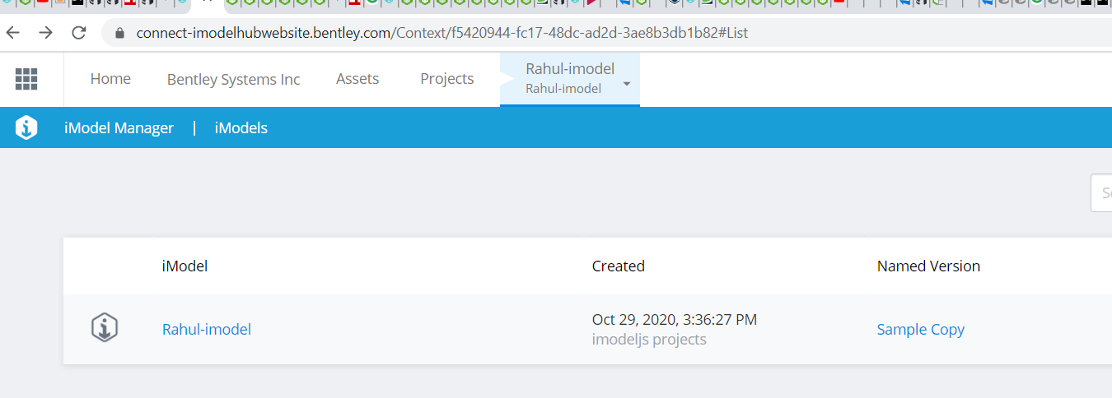

Click on Rahul-iModel

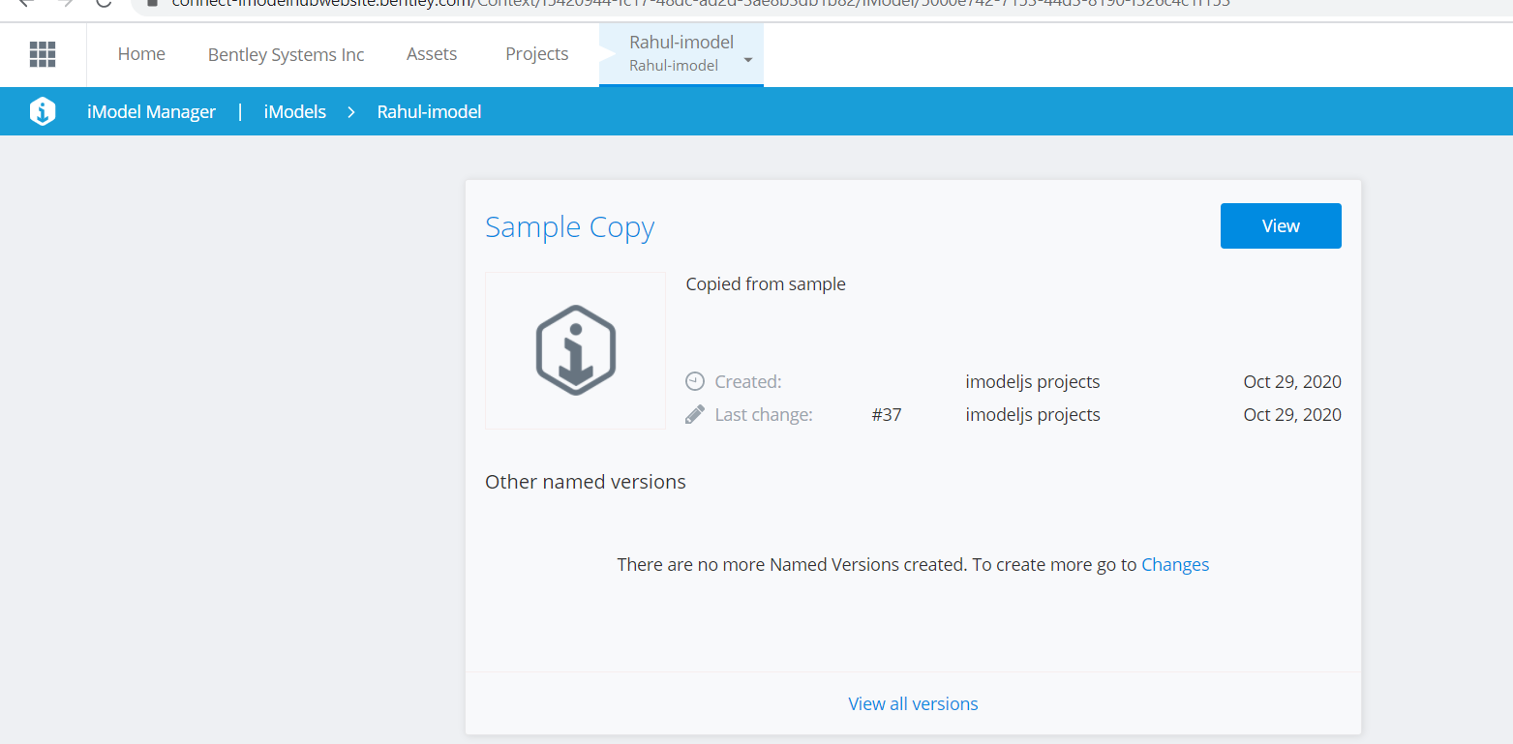

Click on changes

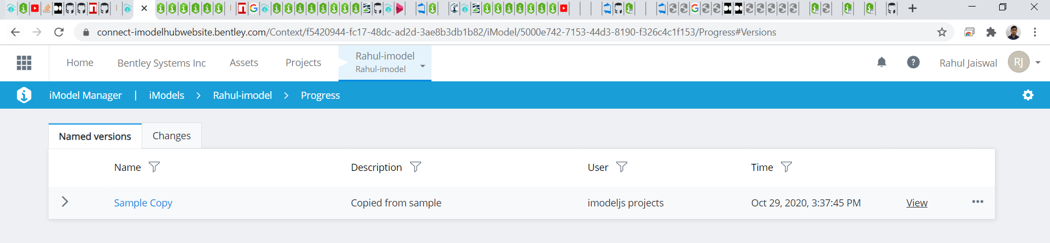

Download from … at right Side

Now we can upload this .bim file for testing if we do not have any .bim iModel File.

Click on sample Copy 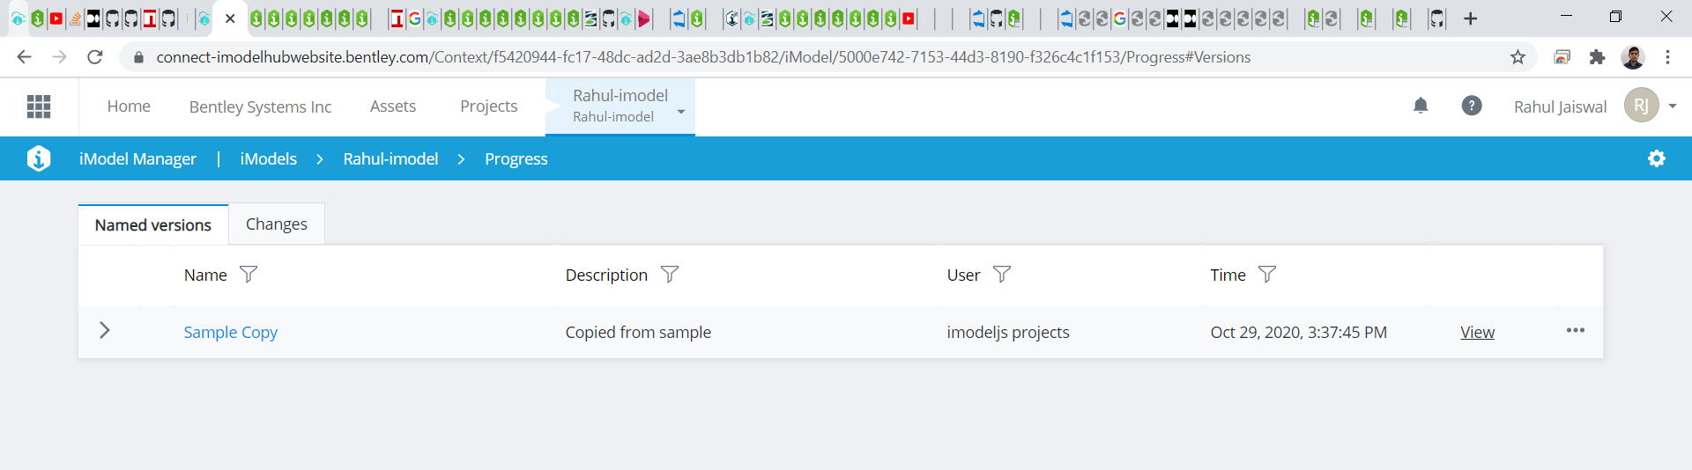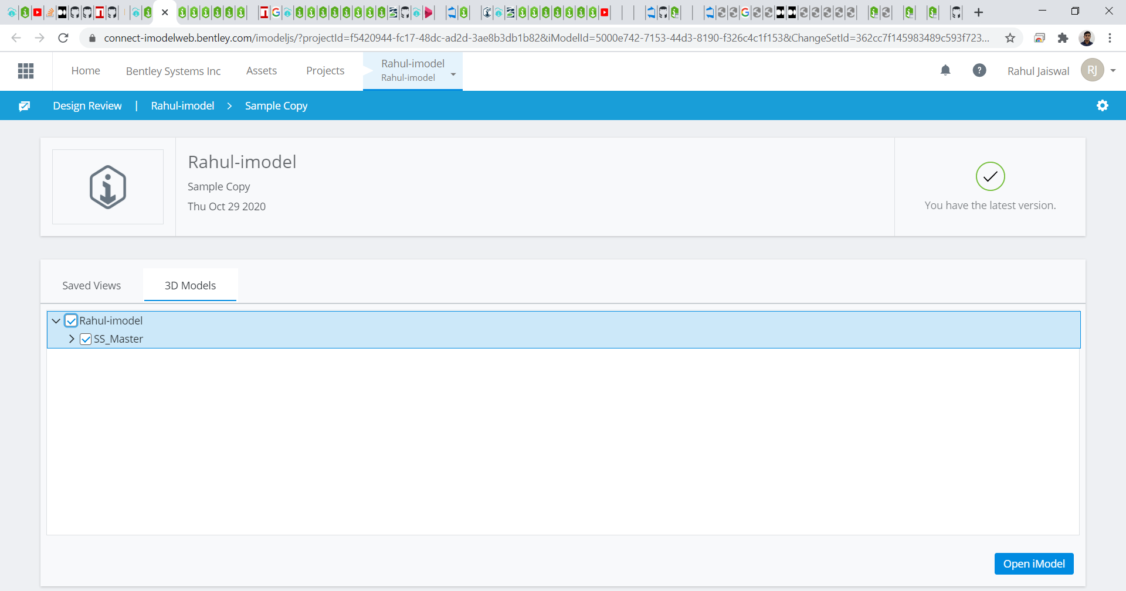

Click on Open iModel

We will get to Design review to show its UI

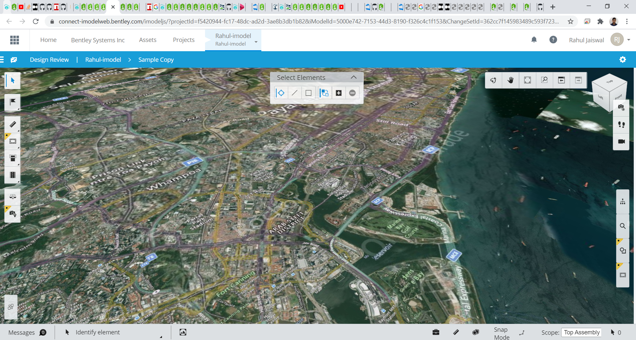

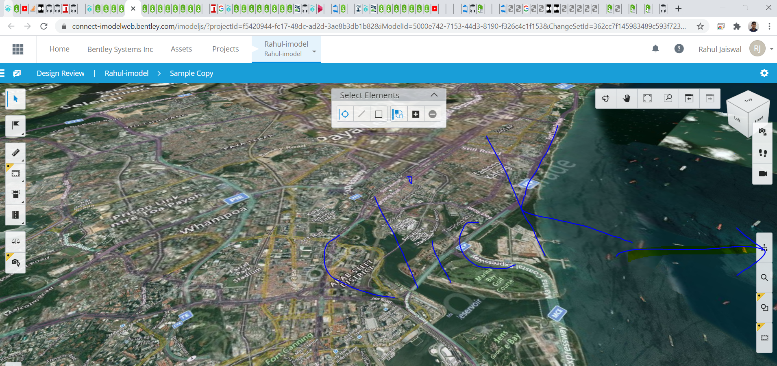

Click here to show Properties

Use Cleat Code from here <https://github.com/Rahul-Jaiswal-dev/Cleat> to Update the iModel

[ Update the Ox1a element using Json file in Cleat Code and the Code will Push rhe ChangeSet to iModeHub , we can see the Changes ]

Query the Elements in iModelconsole to verify the Changeset has been Pushed

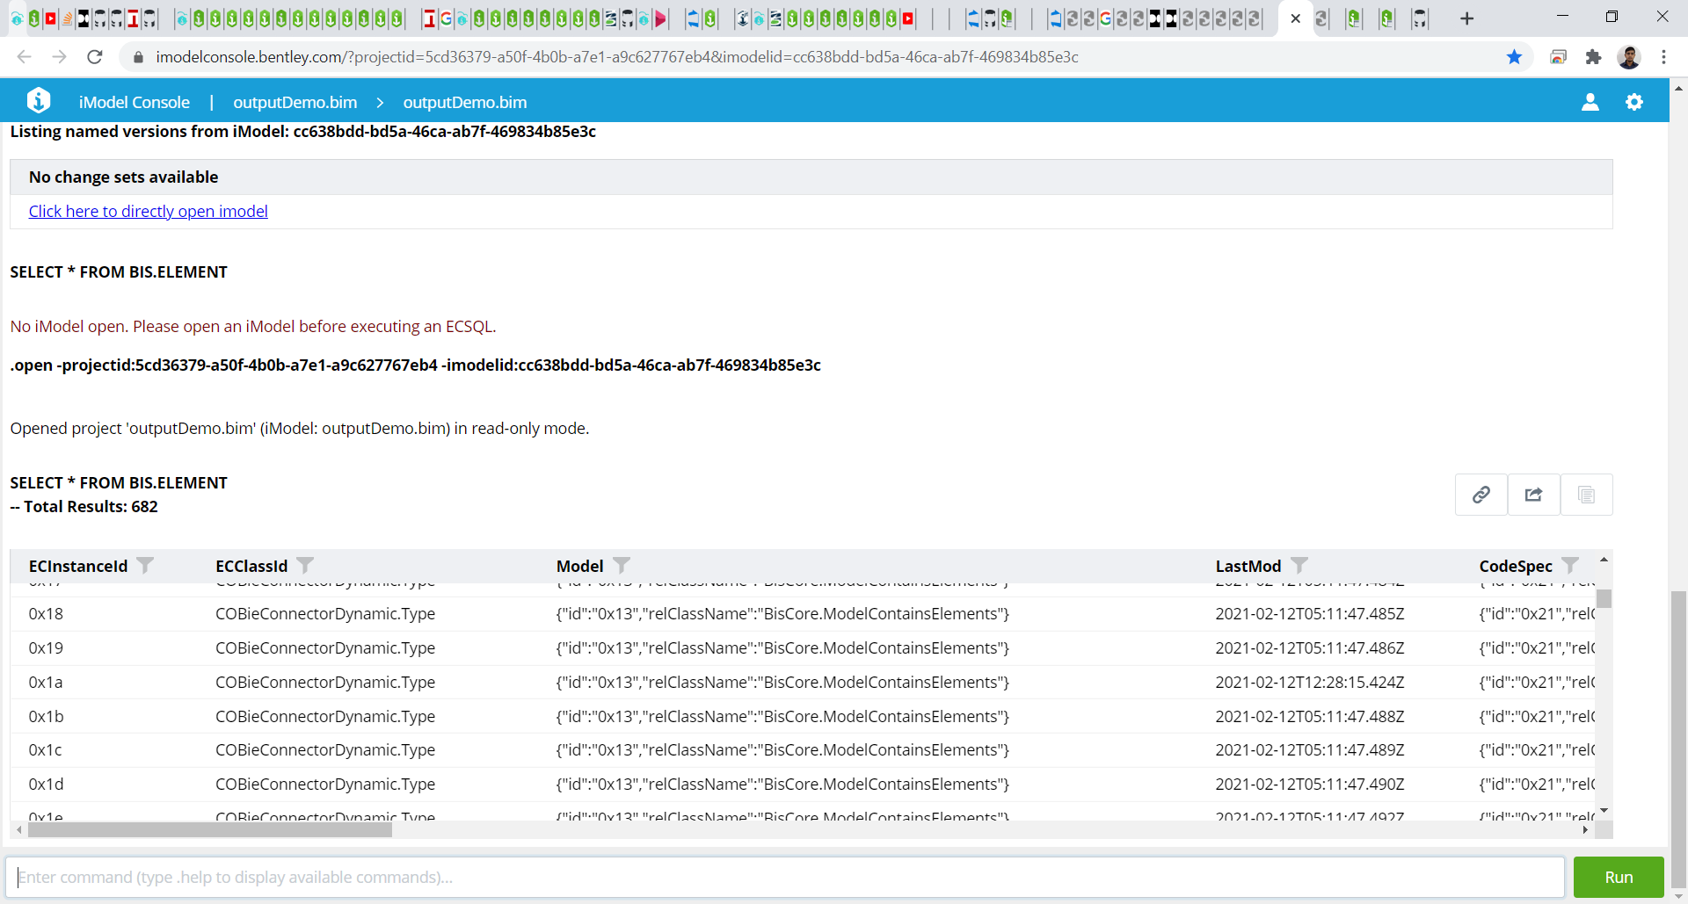

Important Points

1 . ContextId and projectId are same.